Drive Details 2018-19 to 2022-23
Year | Date of the drive | Name of the company | No. of students selected
2018-19 | 04.04.18 | TVSTS | 49
2018-19 | 05.02.2019 | Alcance Technologies | 8
2018-19 | 25.02.2019 | Flextronics Pvt. Ltd., Sricity | 37
2019-20 | 31.7.2019 | Big Basket, Polaris, KIA , INDIGO, RSMIPL | 35
2019-20 | 08.01.2020 | Honda, TATA Foods India Pvt. Ltd, NS Instruments Pvt. Ltd | 40
2019-20 | 10.03.2020 | RSMIPL, TILL HEALTHCARE, KELLOGGS INDIA Pvt. Ltd | 22
2020-21 | 23-3-2021 | Fox Link | 34
2021-22 | 23.11.21 | Apollo Pharmacies Ltd. | 36
2021-22 | 23.12.21 | Bharath FIH(Raising Star Mobile ) | 29
2022-23 | 12.7.2022 | Dixon & Bharath FIH(Raising Star Mobile ) | 24
2022-23 | 18.8.2022 | ICICI | 03
2022-23 | 18.10.22  SRR & CVR College,Vijayawada | Om Logistics | 01
2022-23 | 07.12.22 | TCL (TTE) | 22

Online Courses 2021-22 & 22-23
2021-22 Micro soft Up skilling 24 registered in various degree Programmes 28 students got certificate
2022-23 22 Micro soft Up skilling 32 registered in various degree Programmes course is going on
28 candidates got certificates in MTP Course

Training Details
S.No | Skill | No. Of Hrs Allotted | Trainer
1 | Communication Skills | 60 Hrs | Guest English Mentor (GEM)
2 | Soft Skills | 30 Hrs  10 Hrs | Guest English Mentor (GEM)
3 | Ethical Values | weekend classes | Guest English Mentor (GEM)
4 | Analytical Skills | 60Hrs | Fulltime Mentor working on contract basis
5 | Technical Skills | 60Hrs | Fulltime Mentor working on contract basis
6 | General Awareness | 30Hrs | Fulltime Mentor working on contract basis
 | Total | 250 hrs training package

2018-19 Drive Photos
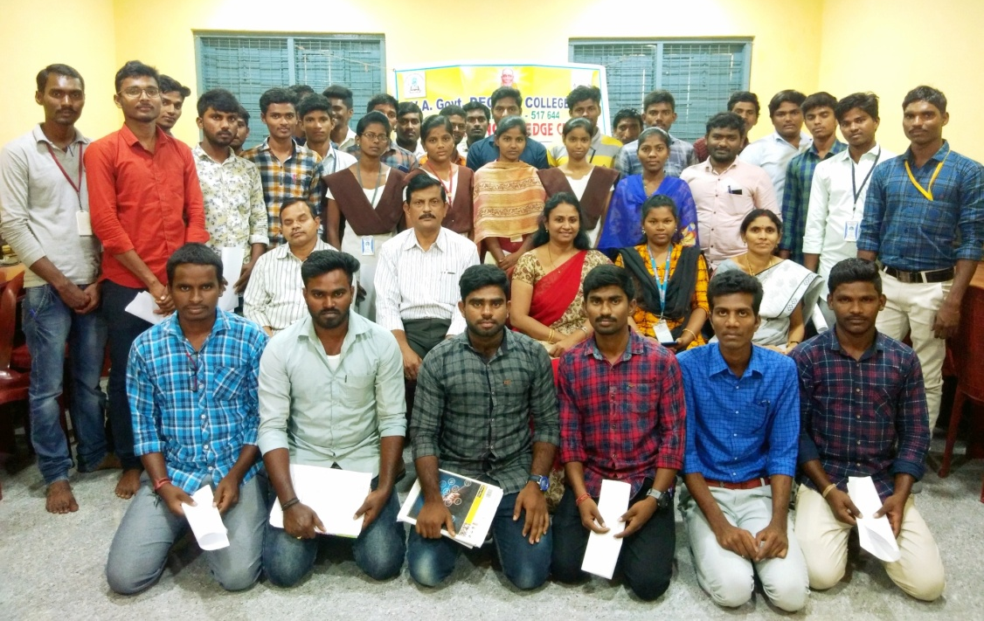
Flextronics Pvt. Ltd., Sricity 25.02.2019
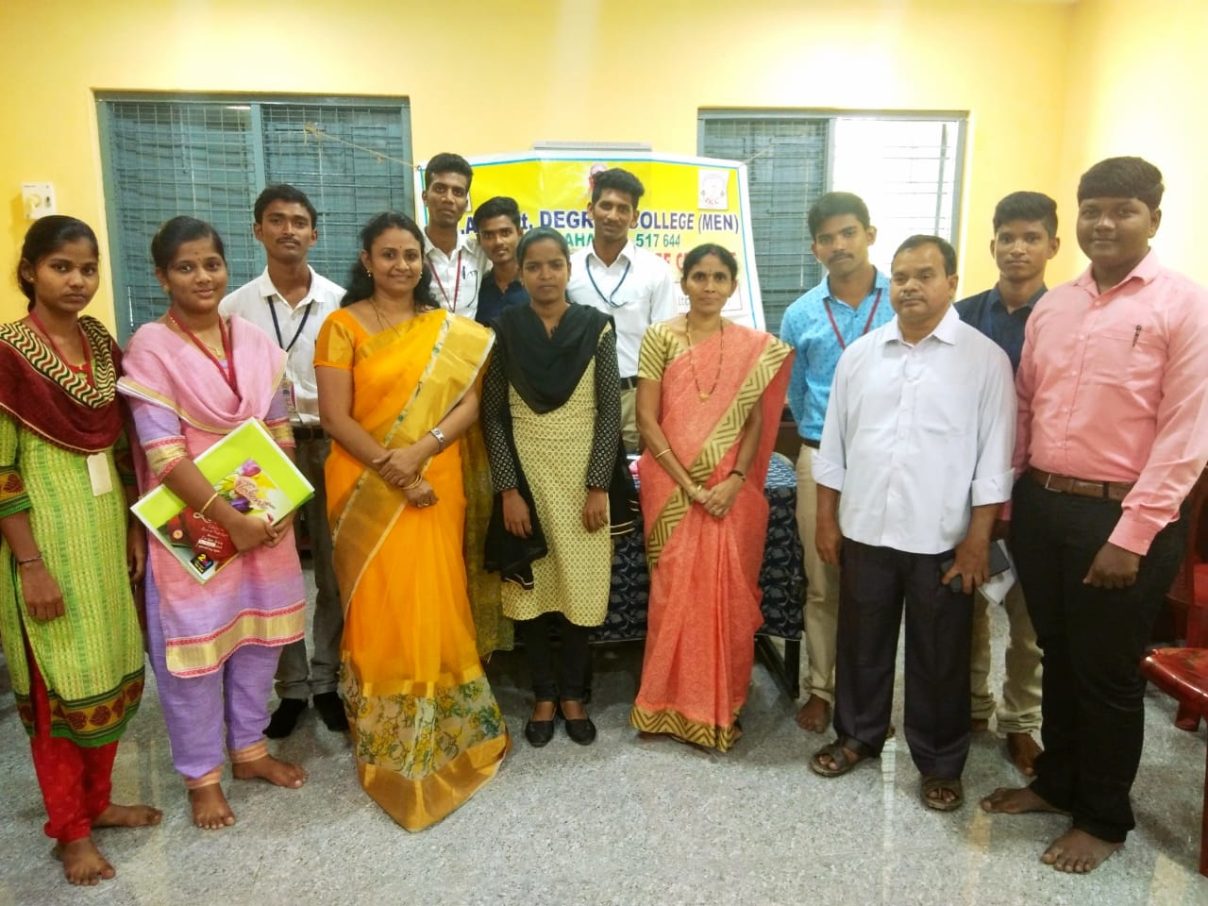
Alcance Technologies Campus Drive on 05.02.2019
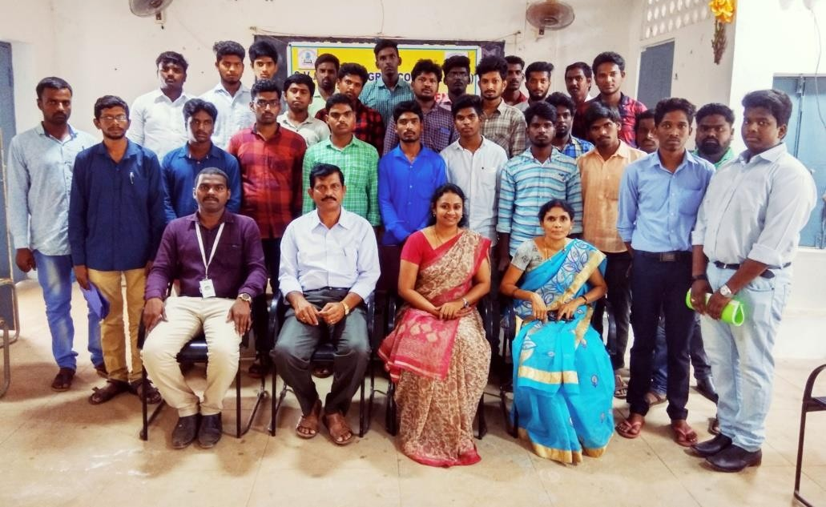
TVSTS Off Campus Drive on 04.04.18
2019-20 Drive Photos
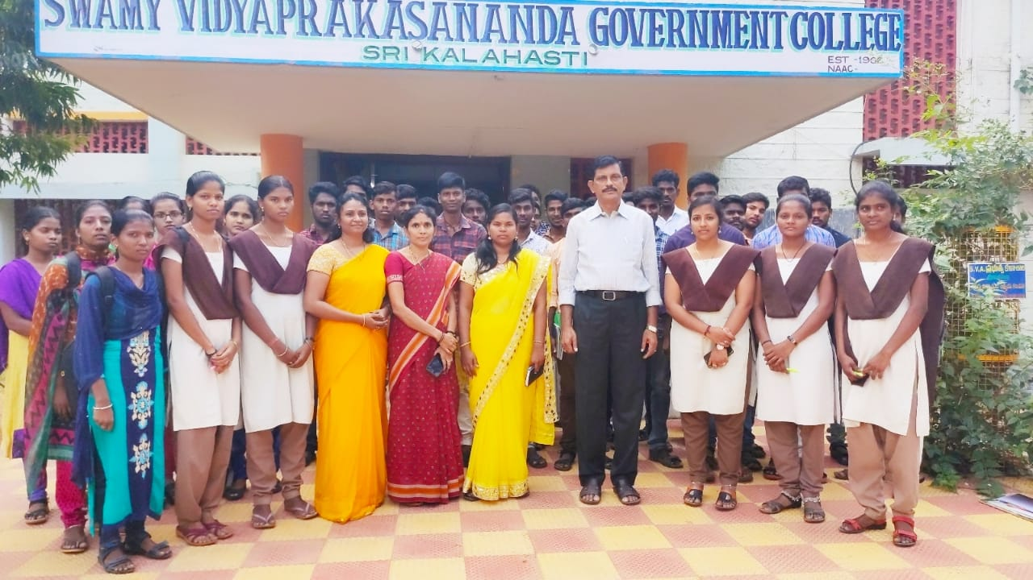
Honda, TATA Foods India Pvt. Ltd, NS Instruments Pvt. Ltd 08.01.2020
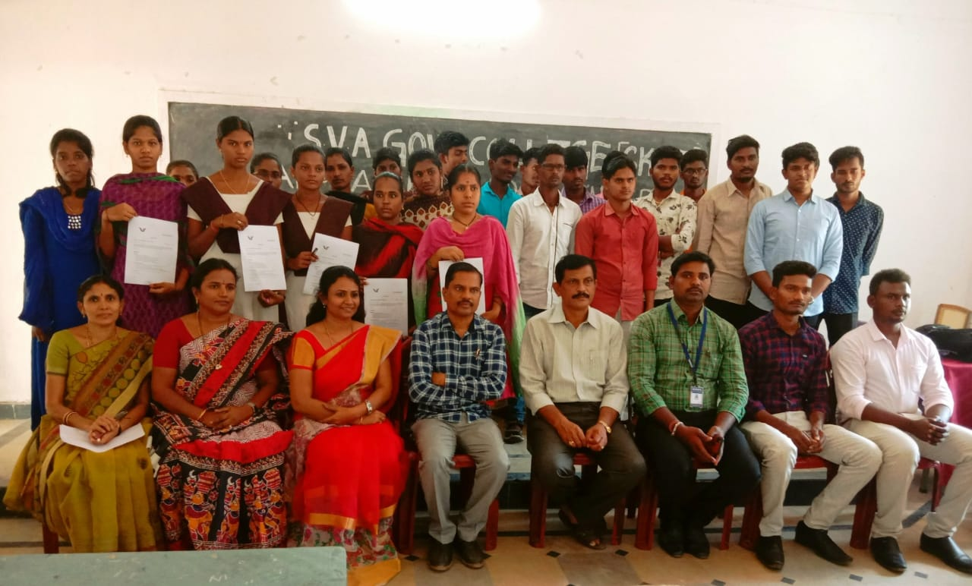
RSMIPL, TILL HEALTHCARE, KELLOGGS INDIA Pvt. Ltd 10.03.2020

2020-21 Drive Photos
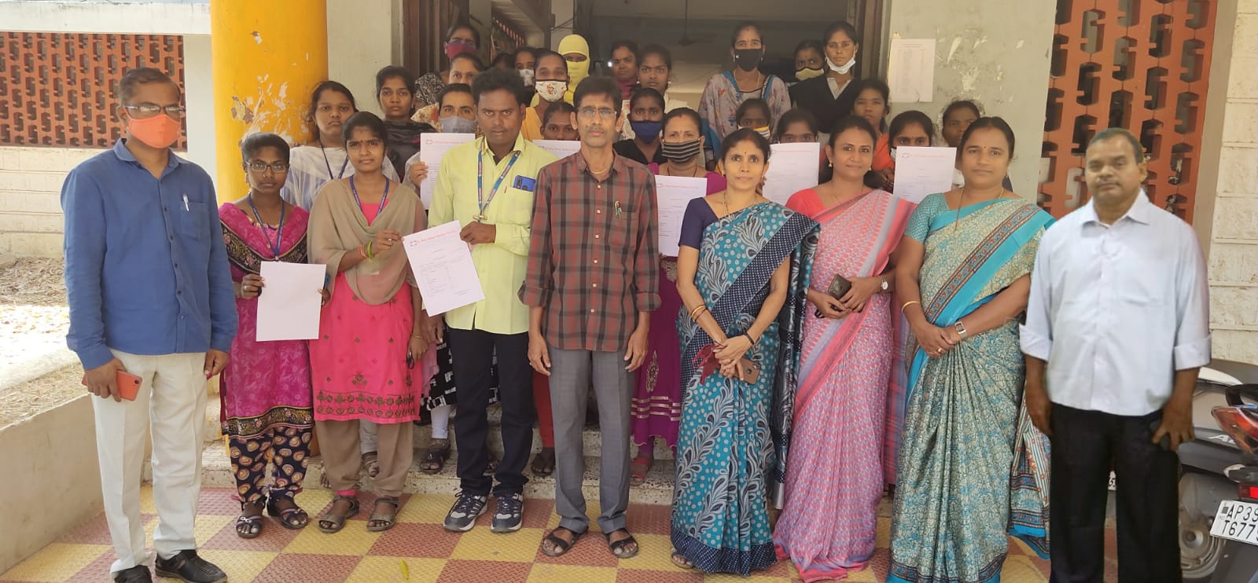
FOX LINK Off Campus Drive 23.03.2021

2021-22 Drive Photos
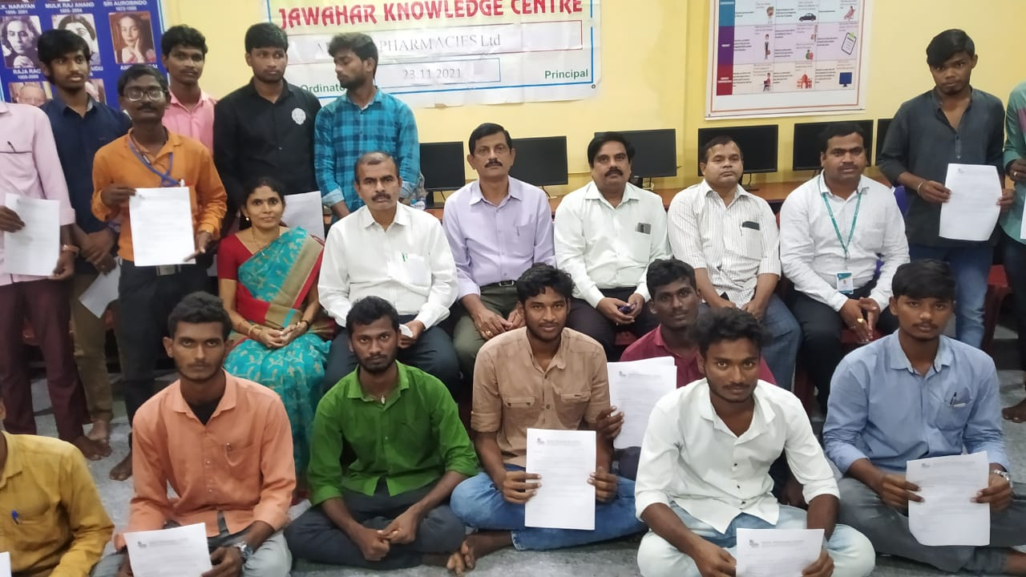
Apollo Pharmacies Ltd 23.11.2021

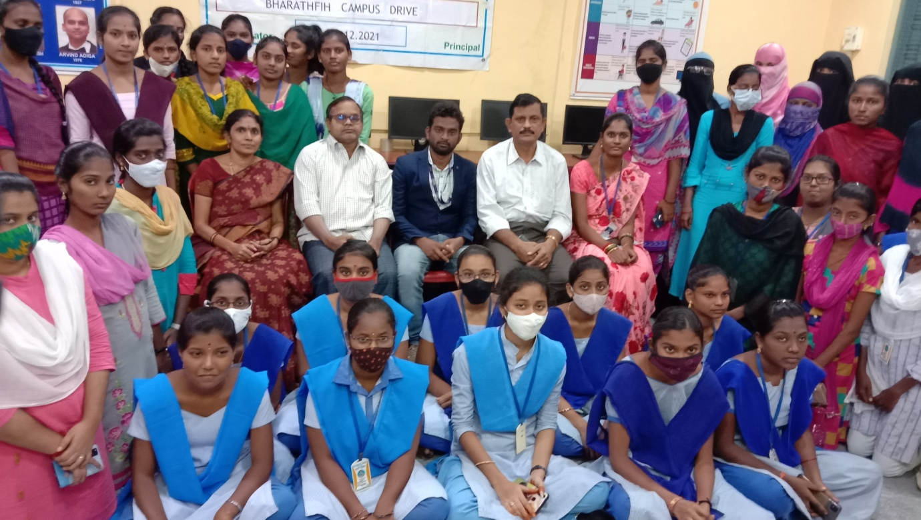
BHARATH FIH OFF CAMPUS DRIVE 23.12.2021

2022-23 Drive Photos
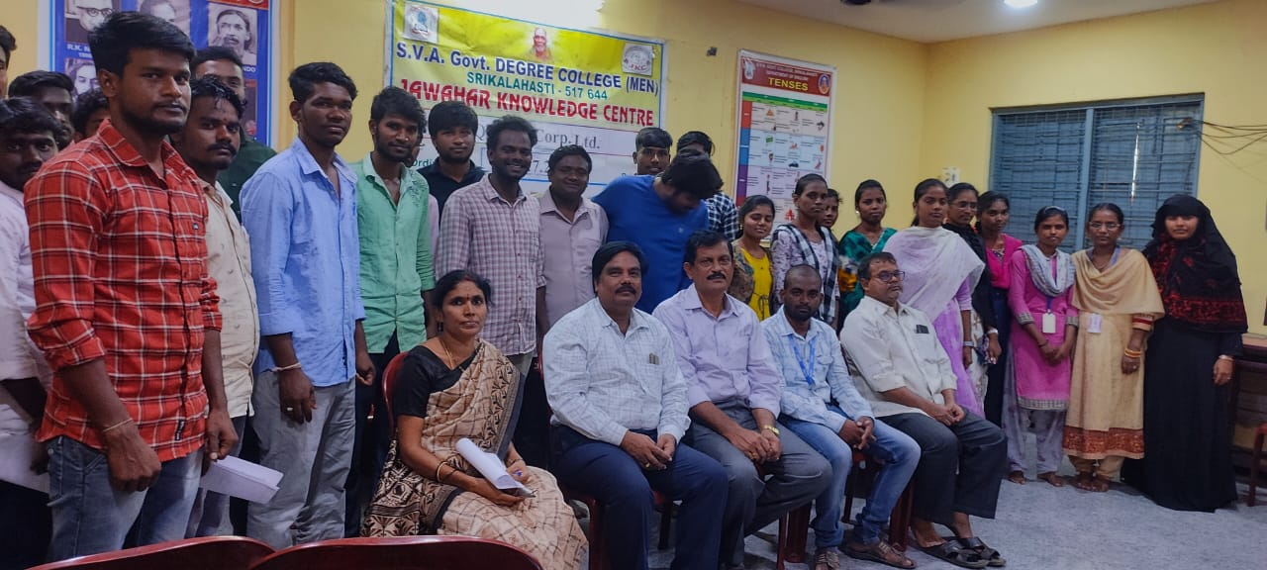
Quess Corp Ltd., 12.07.2022
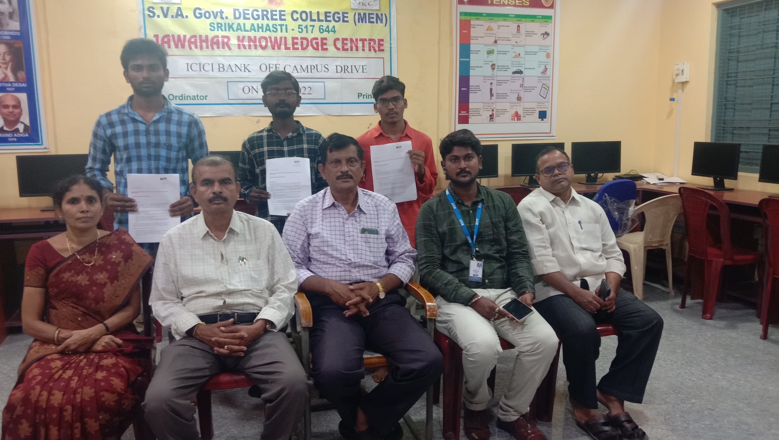
ICICI OFF CAMPUS DRIVE on 18.08.2022
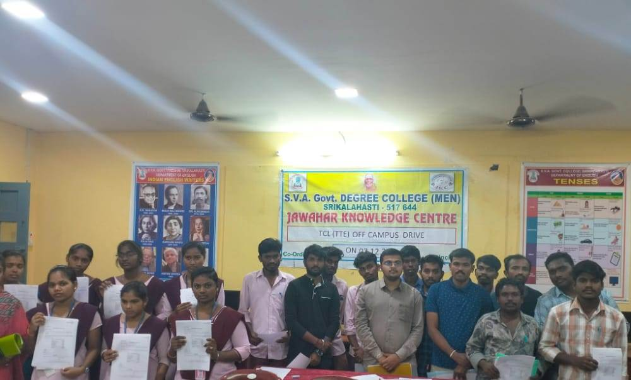
TCL (TTE) CAMPUS DRIVE ON 07.12.22

